CHAPTER 4

4.1 Result

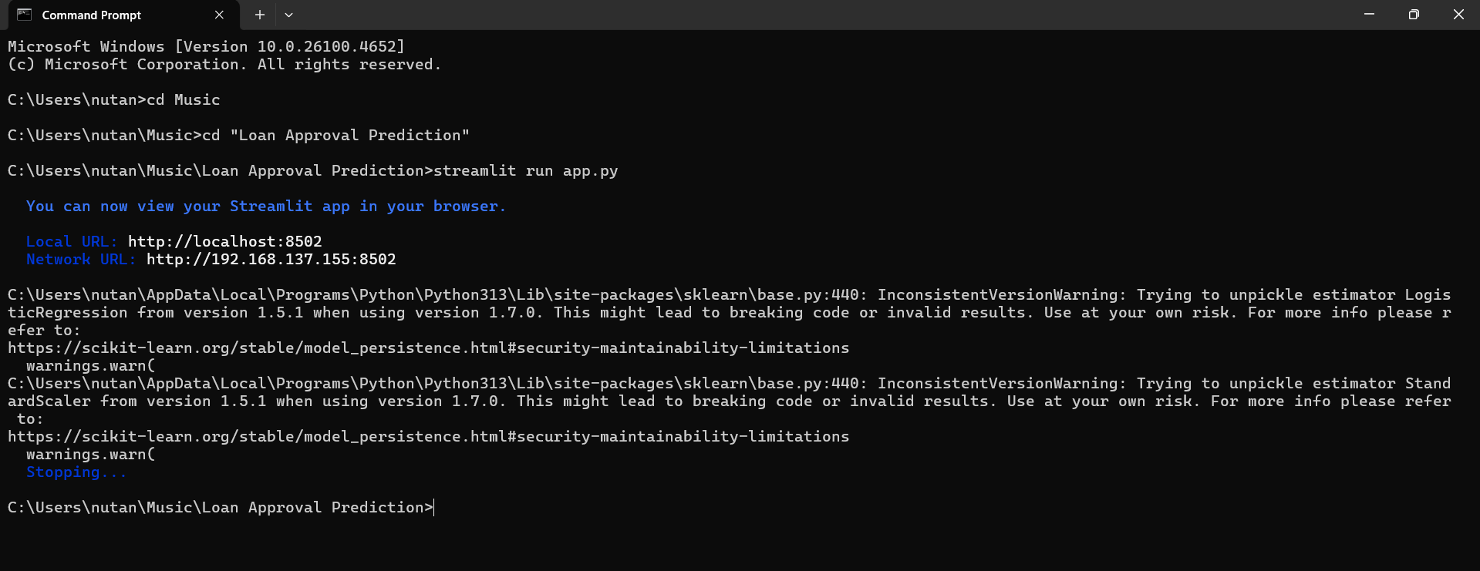

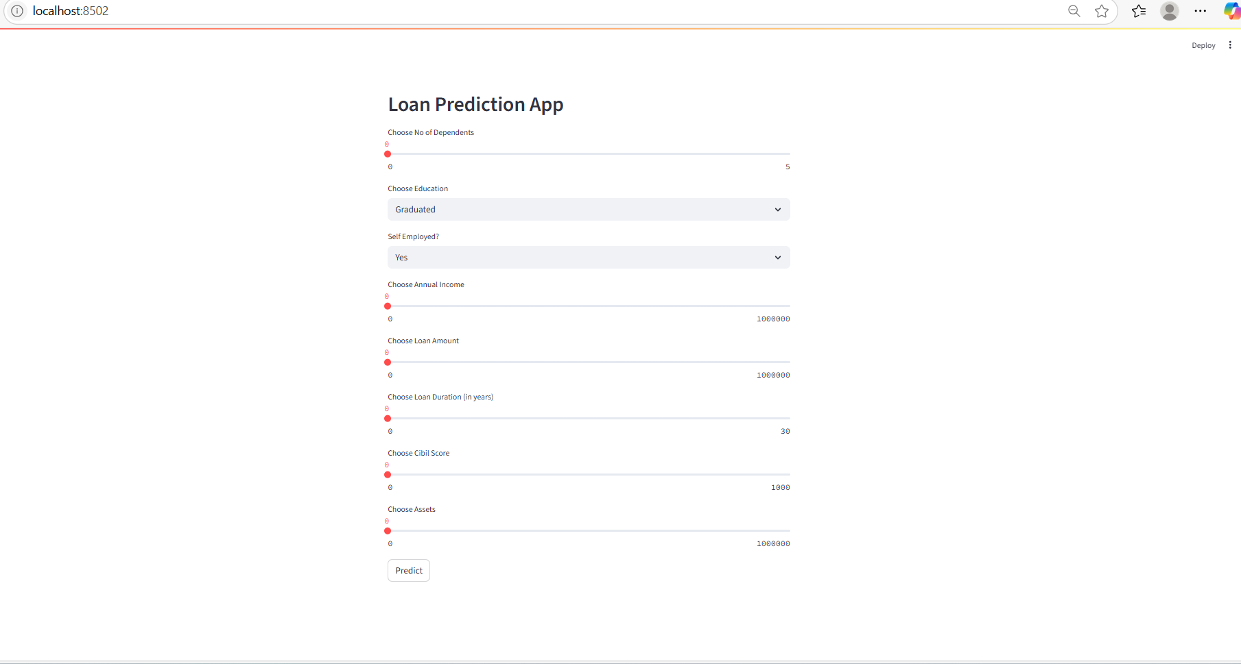

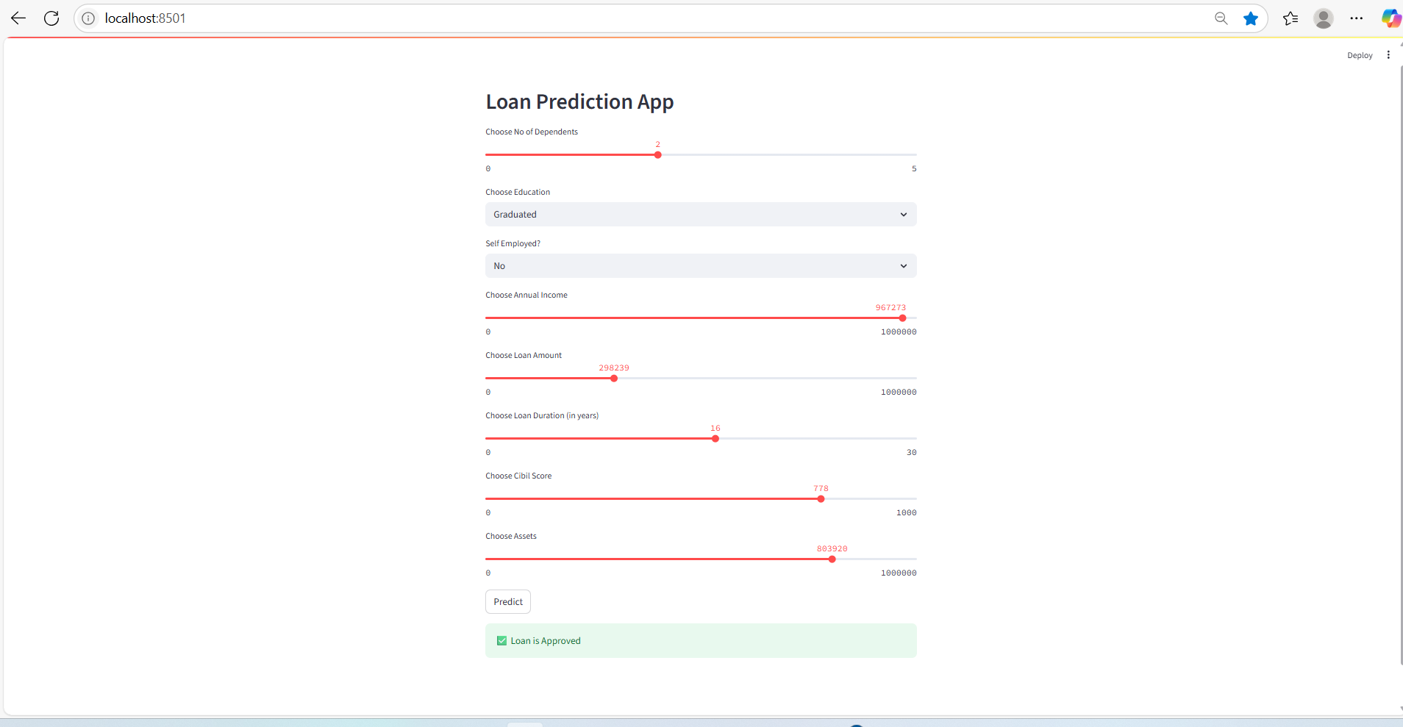

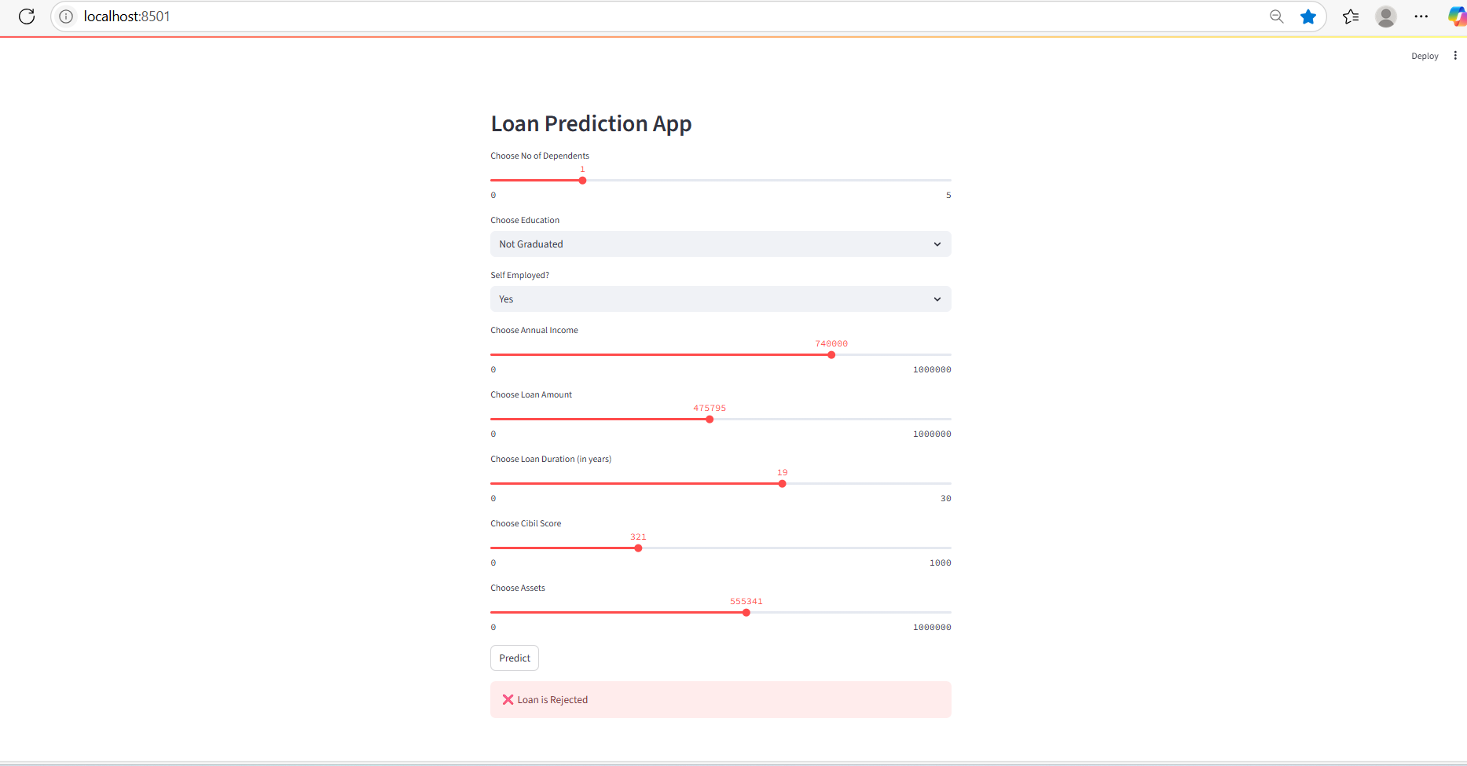

4.2 Technologies Used
1. Backend
- Python 3.11+:
The primary programming language used for the entire backend development, including data preprocessing, model training using machine learning algorithms, and application logic.

2. Frontend
- Streamlit:
A lightweight and user-friendly Python framework used to create an interactive web interface that allows users to input loan application details and view real-time predictions.

3. Libraries and Frameworks
- Scikit-learn:
Used for implementing the Logistic Regression model, along with model evaluation, feature selection, and performance metrics.
- Pandas:
For data loading, cleaning, and manipulation of structured tabular datasets.
- NumPy:
Supports numerical operations and efficient handling of array-based data.
- Joblib:
Used for saving and loading the trained model efficiently.
- Streamlit:
Provides a simple interface for deploying the model in a browser-based environment.

4. Deployment Environment
- Localhost (Development Environment):
The model and Streamlit app were tested and run locally during development.
- Cloud Compatibility (Optional):
The application can be extended for deployment on platforms like Heroku, AWS, or Azure for real-world usage.

5. Tools Used
- Jupyter Notebook / Google Colab:
Used for initial data exploration, preprocessing, training, and visualization.
- VS Code / PyCharm:
Employed for writing and debugging the core backend code.
- Postman (for API testing - optional):
Useful during initial prototype testing in API-based workflows, though not required for Streamlit.

4.3 Discussion
The development of the AI-based loan approval prediction system highlights the practical use of machine learning in automating and improving decision-making processes in the financial sector. Traditional rule-based systems often lack flexibility and scalability, leading to inconsistent evaluations and slower processing times. This project addresses these limitations by building a predictive model that learns from historical loan application data and provides accurate eligibility assessments in real time.
During the implementation, careful attention was paid to key aspects such as data quality, model performance, and user experience. A publicly available dataset containing diverse applicant profiles was selected from Kaggle to simulate real-world lending scenarios. Data preprocessing was a critical step in preparing the dataset, involving tasks such as handling missing values, encoding categorical variables, and scaling numerical features. These steps helped improve the consistency and performance of the model.
Logistic Regression was chosen as the machine learning algorithm due to its interpretability, efficiency, and effectiveness in binary classification problems. The trained model achieved high accuracy and generalizability across different test scenarios. It was serialized using Joblib for deployment and integrated into a user-friendly web application built using Streamlit. This interface allowed users to interact with the model easily, input loan-related details, and receive instant predictions.
The system architecture was designed to be modular and extensible, allowing for future improvements. For instance, additional models like Decision Trees or XGBoost could be integrated for comparison, and explainable AI tools like SHAP could be used to improve transparency in decision-making. The system was tested extensively, and the application consistently delivered fast, reliable, and interpretable results, making it suitable for prototype use in academic or financial environments.
In conclusion, the project successfully demonstrates how machine learning can be effectively applied to the domain of loan approval. It provides a robust foundation for future enhancements and offers significant potential for scaling into real-world applications where speed, accuracy, and fairness are essential in financial decision systems.

